## **COSC 30603**

**Lab Assignment 5: Data Loading and SQL**

You need to turn in: a your answers (type your answer in a different font or color, e.g. **bold face style**) in Microsoft Word format and lab5.sql.

You need to work directly in terminal in for this lab.

Name: Alfredo Perez

Due: Sep 30.

1. Data Loading Documentation

In this assignment, we will first complete data loading. A row-by-row insertion into tables is not efficient for large databases. As an alternative method, data loading allows us to directly load data from files into tables.

MySQL provides a “LOAD” command that can load data stored in a text file into a table. The following illustrates the loading of the data located in dat file into the tables. In the following example, the LOAD command is directly entered at the MySQL prompt. It may be a good idea to create a script file (.sql file) with the load command and use the “SOURCE” command to execute the “LOAD” command. This way, if there are any syntax errors, these can be corrected in the script file and the load command can be re-executed.

MySQL Documentation:

<https://dev.mysql.com/doc/refman/8.0/en/load-data.html>

1. Create a sql file, lab5.sql in Workbench.

We first create the relation schemas.

The schema is based on the EER diagram given on the next page.

What are the entity types and relationship types of the EER diagram that have been implemented in this schema?

Answer:

|  |
| --- |
| ENTITY TYPES: Student, Department, Degree Program, Faculty  RELATIONSHIP TYPES: Chair, Works For, Coordinator, Major |

1. Download lab5_data.zip and unzip it on your computer. E.g. I copied the folder to D:\
2. Enable MySQL LOAD

To enable MySQL’s load data capability, you need to start your MySQL from terminal using:



See this StackOverflow post for more info.

<https://stackoverflow.com/questions/10762239/mysql-enable-load-data-local-infile>

In this lab, if you need to execute load, you have to do that through terminal, NOT Workbench.

1. Open faculty.dat files. Review faculty data in faculty.dat. This is call CSV (Comma-separated values)
2. Execute the following command in terminal to load faculty data into faculty table: Attention: In this example, I installed MySQL on my own local PC. If you are using VMware, you need to first upload lab5 data to centOS. You can use tools like FileZilla, WinSCP, SecureFX etc. Otherwise, you will get “file not found error”

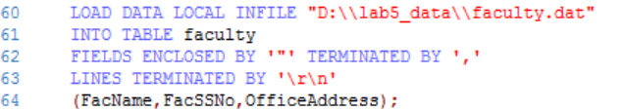

You may check the content of the faculty table now.

select * from faculty;

Is the table properly loaded? Copy the screenshot here:  
YES

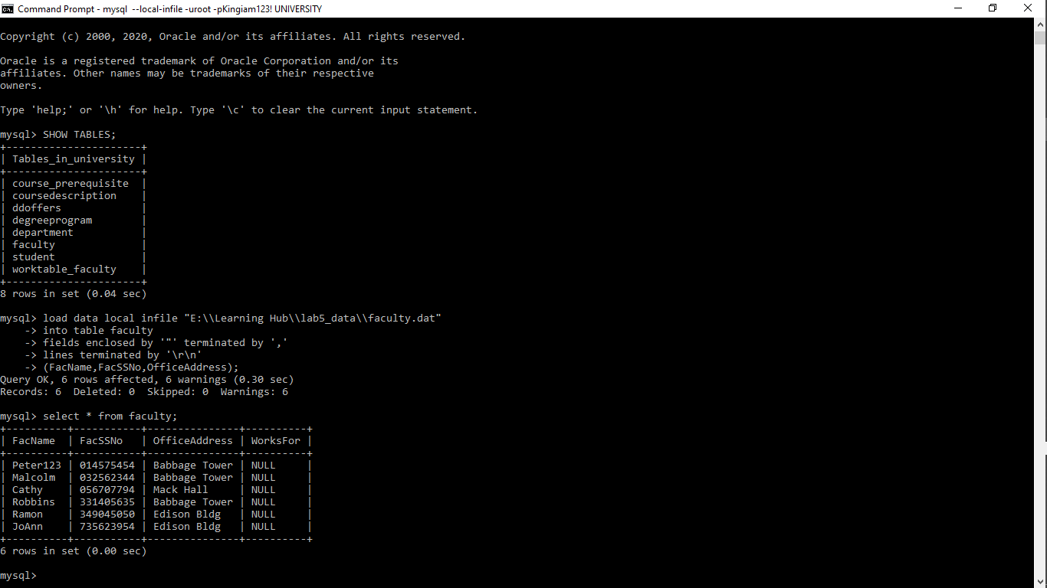

1. Explain the meaning of
   1. Fields enclosed by

|  |
| --- |
| This means, individual values ready to be inserted are bounded by the use of ‘ “ ‘ |

* 1. Terminated by

|  |
| --- |
| This means the values ready to be inserted for a particular row are separated by the use of e.g ‘ , ‘ |



1. Execute the following command in terminal to load department data:

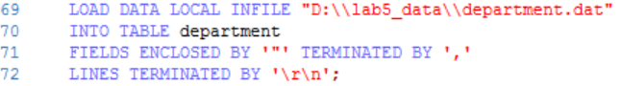

You may check the content of the department table now.

select * from department;

Is the table properly loaded? Copy the screenshot here:

YES

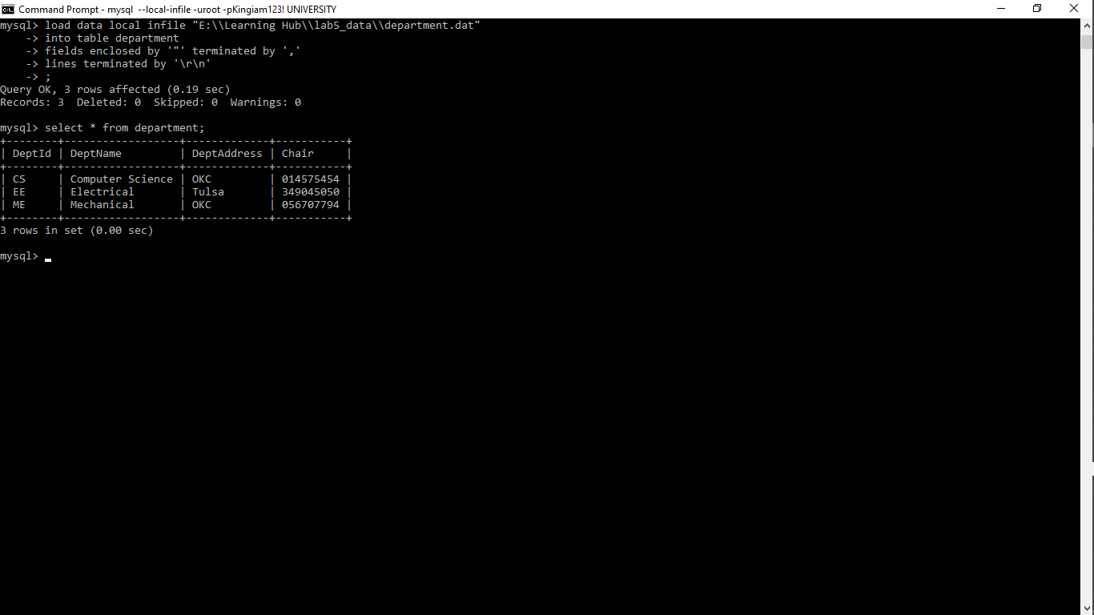

1. We are ready to load the foreign key column, worksfor, of the faculty table now (now, they are NULL). We need to use SQL UPDATE to do this.
2. The foreign key data is first loaded into the temporary table **worktable_faculty**. Note that we do not have a corresponding worktable_faculty.dat file. So we need to extract some columns from faculty.data using the following command:

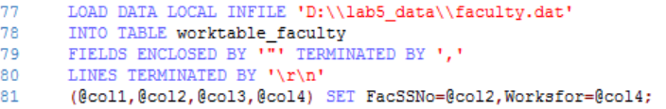

Explain the meaning of

* 1. (@col1, @col2, …@col4)

|  |
| --- |
| The above are variable names created to store the data that is being loaded from the faculty.dat file. |

* 1. SET FacSSNo=@col2

|  |
| --- |
| The statement means, the value stored in @col2 should be assigned to the column FacSSNo in the worktable_faculty table |

You may check the content of the worktable_faculty table now.

select * from worktable_faculty;

Is the table properly loaded? Copy the screenshot here:

YES

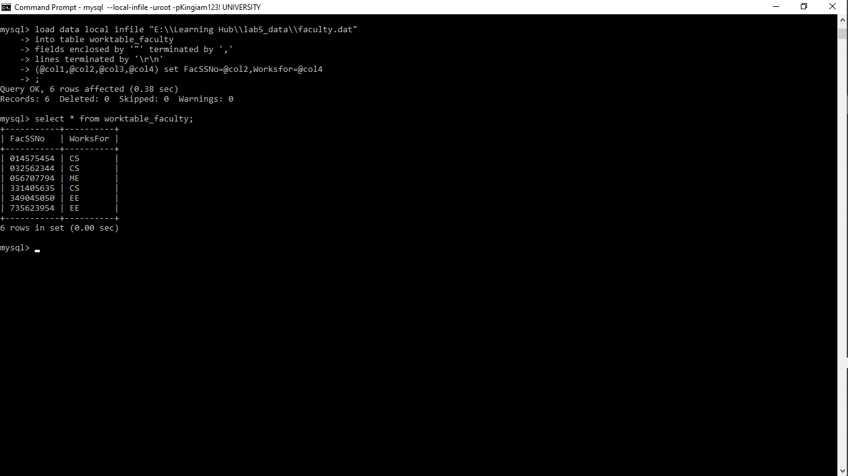

1. Now update the worksfor column of the Faculty table using the following SQL command:

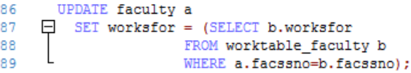

Note the syntax of the update statement, which is a correlated nested SQL statement. Also note that, to assign the query result into a column, the statement must guarantee that the result set contains only one record value. Otherwise, the statement will not work.

Now check the content of the faculty table in Workbench and copy your answer here.

select * from faculty;

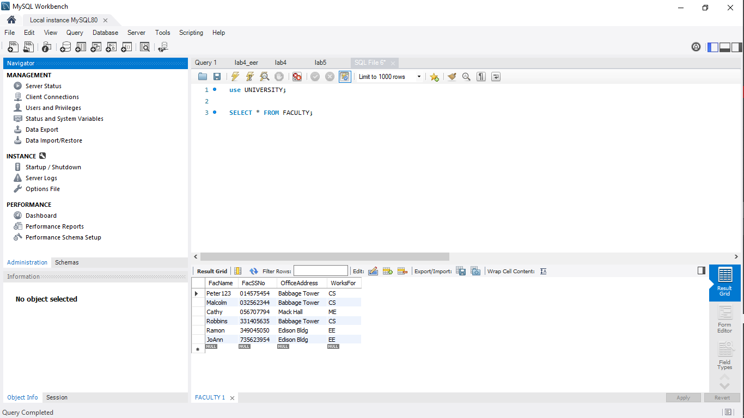

1. Load data for tables DegreeProgram, Student and DDoffers.

Can we load DDoffers before DegreeProgram? Why?

Answer:

|  |
| --- |
| NO  The column ProgId references the primary key of the DegreeProgram table ProgId In this case, it hasn’t been populated yet, hence there is no value to reference making it impossible to load DDoffers before DegreeProgram. |

Copy your SQL code for loading the three tables here:

|  |
| --- |
| DEGREE PROGRAM  load data local infile "E:\\Learning Hub\\lab5_data\\degreeprogram.dat"  into table DegreeProgram  fields enclosed by '"' terminated by ','  lines terminated by '\r\n'  ;  STUDENT  load data local infile "E:\\Learning Hub\\lab5_data\\student.dat"  into table Student  fields enclosed by '"' terminated by ','  lines terminated by '\r\n'  ;  DD OFFERS  load data local infile "E:\\Learning Hub\\lab5_data\\ddoffers.dat"  into table ddoffers  fields enclosed by '"' terminated by ','  lines terminated by '\r\n'  ; |

1. Now we will review some algebraic expressions and the corresponding SQL statements.

(a) σmajor='P000' Student

Give the meaning of the expression in English.

Answer:

|  |
| --- |
| Get records of students who have their major being P000 |

Run the following equivalent SQL statement and check your answer.

select * from student where major='P000';

Screenshot:

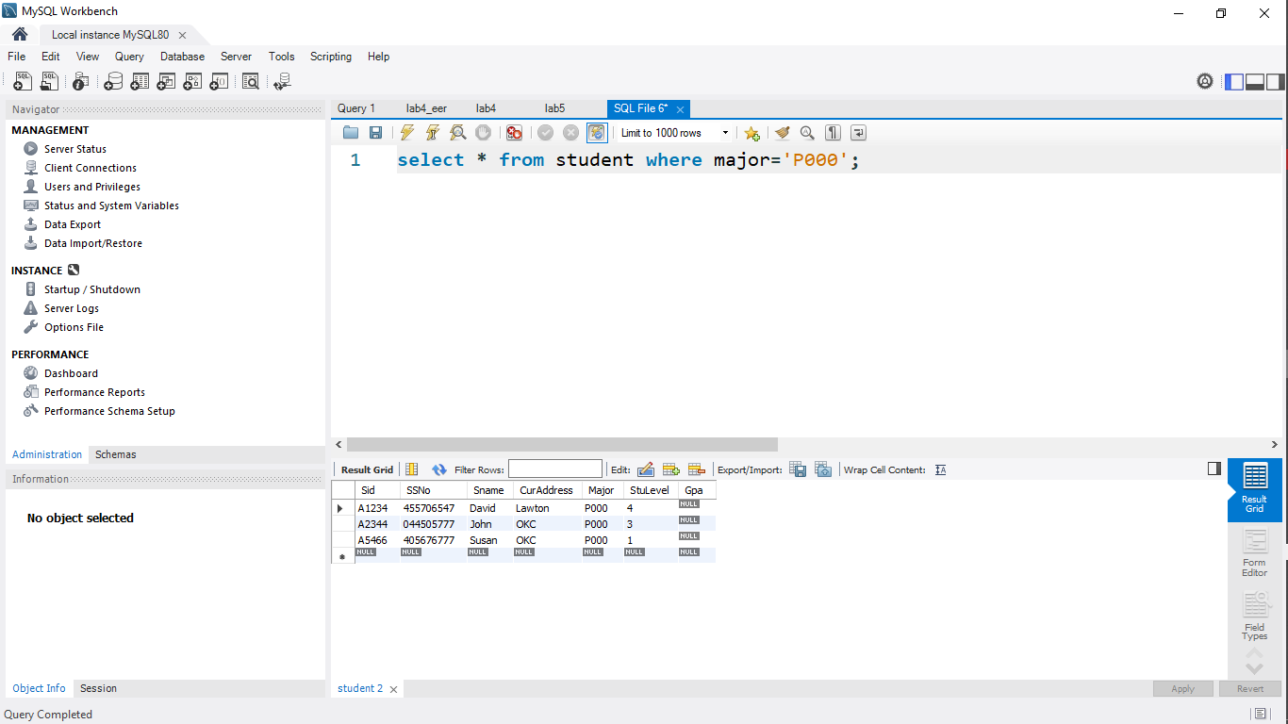

(b) πsid, sname σmajor='P000' Student

Give the meaning of the expression in English.

Answer:

|  |
| --- |
| Get student id, student name of students who have their major being P000 |

Run the following equivalent SQL statement and check your answer.

select sid, sname from student where major='P000';

Screenshot:

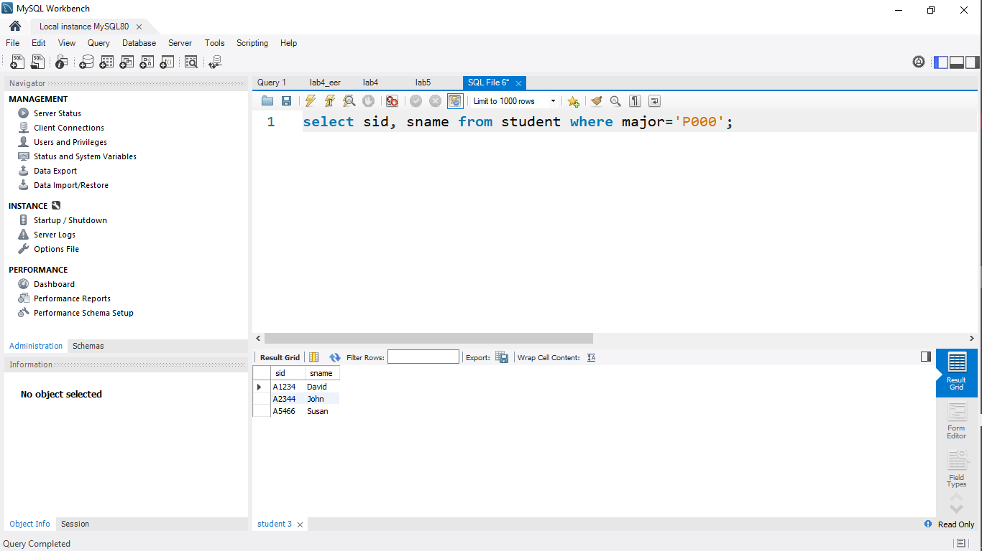

(c) πfacssno, facname σworksfor='CS' Faculty

Give the meaning of the expression in English.

Answer:

|  |
| --- |
| Get faculty ssn, faculty name from all Faculties that works for the department CS |

Write an equivalent SQL statement and run it to check your answer.

Answer:

|  |
| --- |
| select facssno,facname from Faculty where worksfor = “CS”; |

Run the equivalent SQL statement and check your answer.

Screenshot:

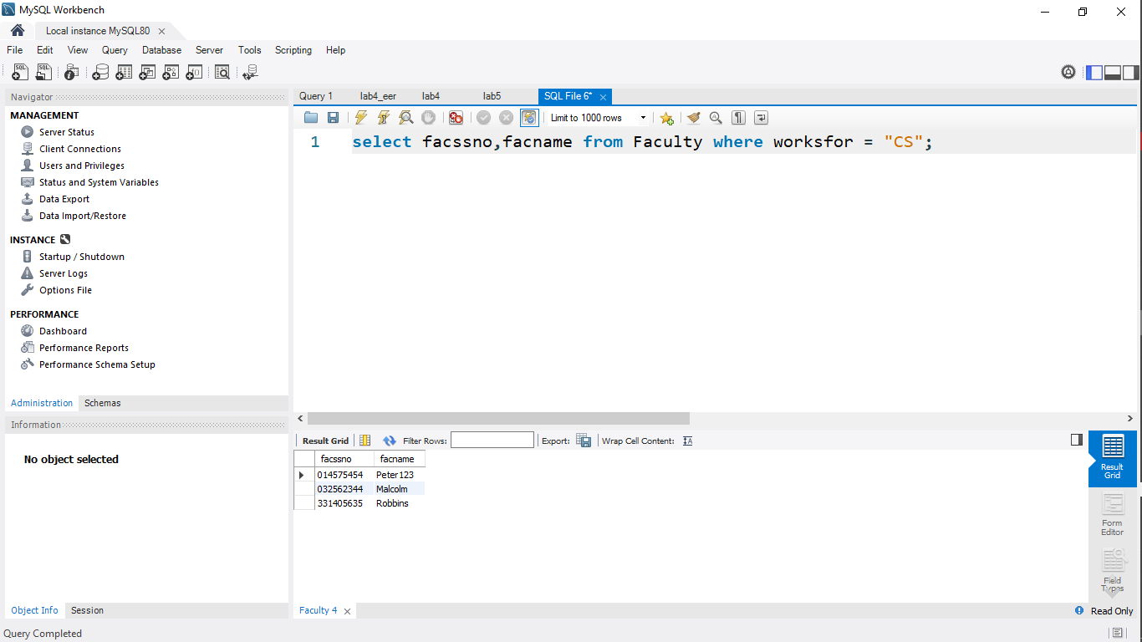

1. Consider the following query in English:

Get program id and program name of all programs that offer BS degree.

(a) Give an algebraic expression for the query.

Answer:

|  |
| --- |
| π ProgId,ProgramName σ ProgType=’BS’ DegreeProgram |

(b) Write an equivalent SQL statement.

Answer:

|  |
| --- |
| Select ProgId, ProgName from DegreeProgram where ProgType = “BS” |

Run the equivalent SQL statement and check your answer.

Screenshot:

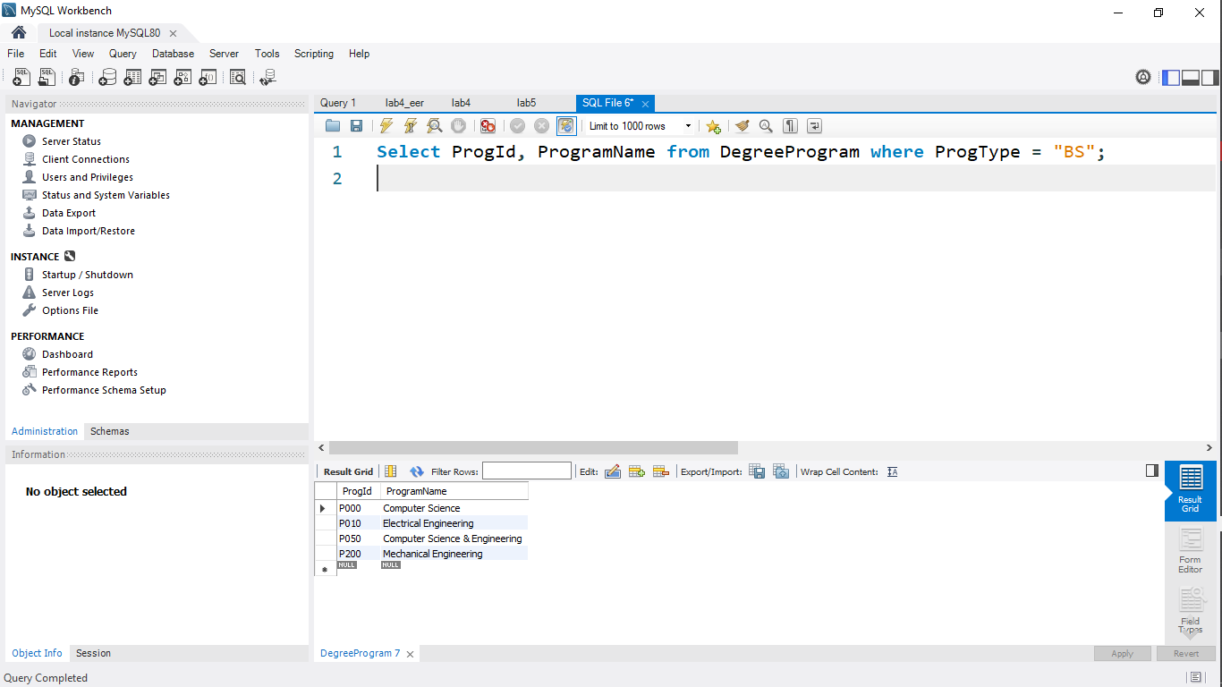

1. Run the following SQL statement

select * from faculty, department;

(a) What is the meaning of the SQL statement?

Answer:

|  |
| --- |
| It returns the results of both faculty and department combined |

(b) Give an equivalent relational algebraic expression.

Answer:

|  |
| --- |
| π * (Faculty x Department) |

Run the equivalent SQL statement and check your answer.

Screenshot:

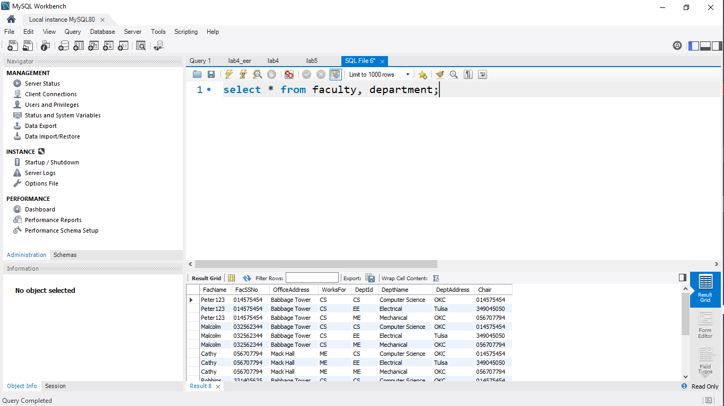

1. πfacssno, facname, deptname σworksfor=deptid (Faculty × Department)

(a) Give the meaning of the expression in English.

Answer:

|  |
| --- |
| The expression gets the faculty ssn, faculty name, department name where there is equality between works for and department id from tables faculty and department |

(b) Run the following equivalent SQL statement and check your answer.

select facssno, facname, deptname

from faculty, department

where worksfor=deptid;

Screenshot:

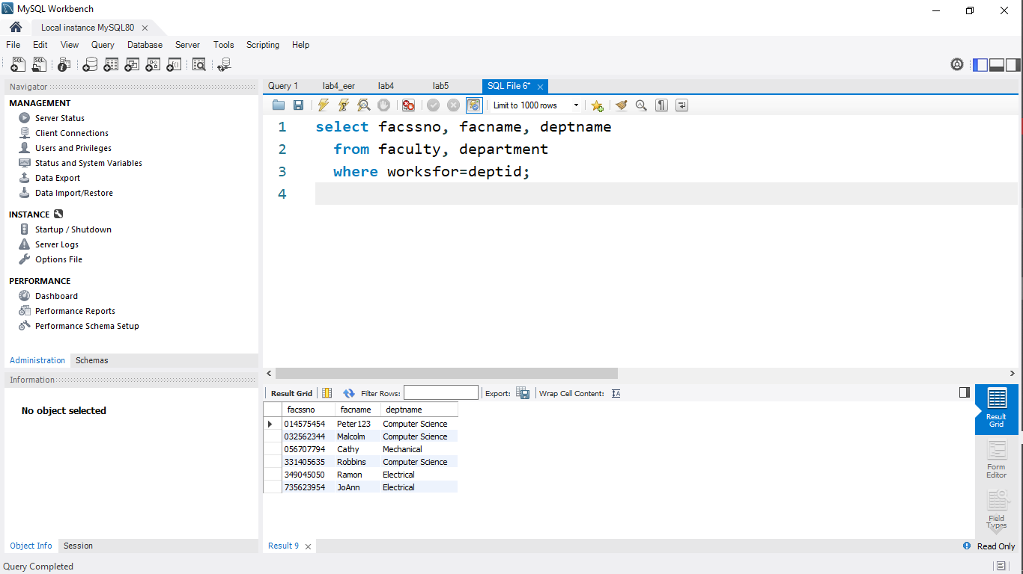

1. πfacssno, facname, deptname

σworksfor=deptid and (officeaddress='Babbage Tower' or officeaddress='Edition Bldg')  (Faculty × Department)

(a) Give the meaning of the expression in English.

Answer:

|  |
| --- |
| The expression gets the faculty ssn, faculty name and department name where the faculty works for is the same as the department id and office address equals Babbage Tower or Edition Bldg from tables Faculty and Department |

(b) Run the following equivalent SQL statement and check your answer.

select facssno, facname, deptname

from faculty, department

where worksfor=deptid and

(officeaddress='Babbage Tower'

or officeaddress='Edition Bldg');

Screenshot:

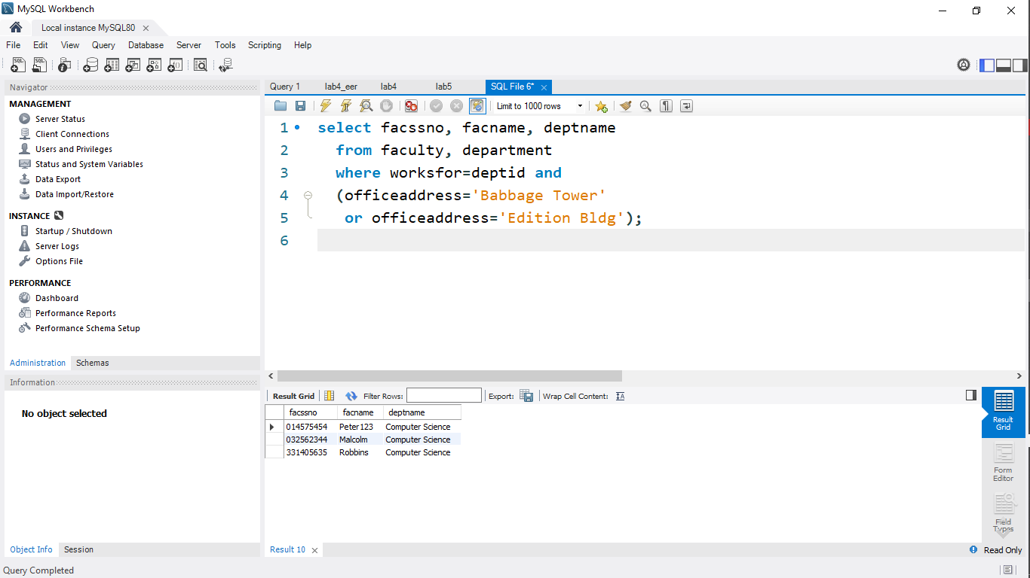

1. Consider the following query in English:

Get student id, student name, program name and program type of all students from OKC and at levels less than or equal to 4.

(a) Give an algebraic expression for the query.

Answer:

|  |
| --- |
| π Sid,Sname,ProgramName,ProgType σ Major = Progid and CurAddress = ‘OKC’ and StuLevel <=4  (Student x DegreeProgram) |

(b) Write an equivalent SQL statement.

Answer

|  |
| --- |
| Select Sid,Sname,ProgramName,ProgType from Student,Degreeprogram where Major=Progid and CurAddress = “OKC” and StuLevel <= 4 |

(c) Run the statement in SQL to verify the answer.

